A+ Computer Science SPIRAL RUN

Lab Goal: This lab was designed to help you get more comfortable with using loops and using them to create more efficient Jeroo methods. You must also show mastery solving more complex problems. Loops will eliminate repetitive code such as repeatedly calling hop in order to cover large portions of the island

Lab Description: Create a single method that would allow your Jeroo to spiral from the start to the middle of the island where the flower is located. When you reach the flower, you will stop facing it. Once you have successfully spiraled to the center of the island, check out the bonus and see if you can spiral back to the start location.
Sample Start:
Files Needed ::
spiral.jsc
spiral.jev

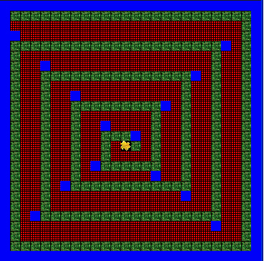
algorithm help

Plan the method and determine what is needed to complete the problem.

Preconditions –
- Jeroo starts at 0,0
- Jeroo is traveling EAST

Postconditions –
- Hopped to the center of the Island
- Did not collide with any nets or water.
- Stops facing the flower.

Test the method before using it more than once.

Sample Ending:

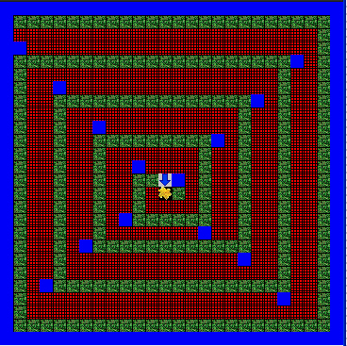

Bonus: Write another method called spiralOut() to spiral the Jeroo back to the original start location. Also, use recursion to write both methods for a bigger bonus.

